
No.06: 2024/25 Cropping Season Review of November 21-30, 2024, and Outlook for December 1-10, 2024

SYNOPTIC SUMMARY DURING

NOVEMBER 21-30, 2024

HIGHLIGHTS
- The expected heavy rain over western regions and the Lake Victoria basin may likely affect crops due to excessive soil moisture and waterlogging
- Farmers over bimodal areas who did not plant crops during October and Early November are advised to consult the extension officers from their localities before planting crops since the end of the VULI rains season is approaching.
- Water users are advised to harvest rainwater for future use

D

uring the dekad, the southern hemisphere high pressure systems (St. Helena and Mascarenes) continued to relax while the northern hemisphere high pressure systems (Azores and Siberian) continued to intensify. This condition maintained the gradual southward movement of the meridional arm of the Inter-Tropical Convergence Zone (ITCZ), into areas along Lake Victoria Basin, the western, central part of our country, and southwestern highlands.

On the other hand, the Sea Surface Temperatures (SSTs) over the area between north of Madagascar and the East African coast were warmer than normal. This condition enhanced the formation of low-pressure systems over that area, improving the precipitation-making mechanisms (a zonal arm of ITCZ) over coastal areas of our country and nearby areas.
The above weather systems resulted in thundershowers over the Lake Victoria Basin, central areas, and western parts. Periods of rain showers were also observed over the coastal regions, southwestern highlands, and northeastern highlands.

RAINFALL PERFORMANCE DURING

NOVEMBER 21-30, 2024

0

D

uring the dekad, most areas of the country experienced rainy conditions with amounts ranging from 1 mm to 100 mm. However, a few areas over Tabora, Mara, Manyara, and Kilimanjaro experienced dekadal rainfall of more than 100 mm as shown in Figure 1.
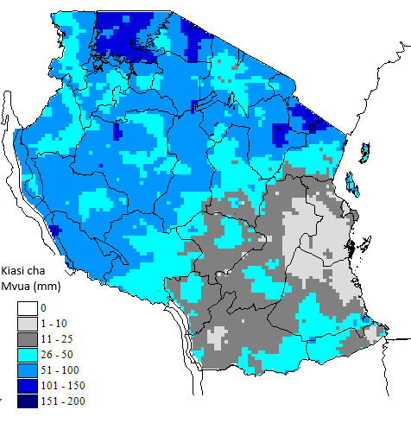
Figure 1: Total dekadal rainfall for November 21-30, 2024

AGROMETEOROLOGICAL SUMMARY

DURING NOVEMBER 21-30, 2024

D

uring the dekad under review, some areas of the country experienced rainy conditions that supported crop establishment particularly maize that are in vegetative stages around the Lake Victoria basin and Northern coast.

AGROMETEOROLOGICAL SUMMARYDURINGMAY11-20, 2022

This condition also supported the crop planting activities over the unimodal areas particularly in Tabora, Kigoma, and Katavi regions where maize crops are between emergence and third leaf stages.

Dry and sunny conditions experienced in most areas of Pwani, Tanga, and Dar es Salaam affected the maize crop growth which was at the vegetative stage.

Water and pasture for livestock and wildlife continued to improve particularly in the areas that experienced rain conditions.

HYDROMETEOROLOGICAL CONDITIONS

DURING NOVEMBER 11-20, 2024

T

W

ater levels in dams and river flow discharges slightly increased particularly over Lake Tanganyika and Victoria basin.

EXPECTED SYNOPTIC CONDITIONS

DURING DECEMBER 1-10, 2024

D

uring this period, the southern hemisphere high pressure systems are expected to continue relaxing while the northern hemisphere high pressure systems are expected to continue intensifying. This condition is expected to maintain the gradual southward movement of the meridional arm of the ITCZ, into areas along the Lake Victoria Basin, the central, western part of our country, and the southwestern highlands.

On the other hand, the SSTs over the area between north of Madagascar and the East African coast are expected to be warmer than normal. This condition is expected to enhance the formation of low-pressure systems over that area, improving the precipitation-making mechanisms (zonal arm of ITCZ) over coastal areas of our country and nearby areas.

EXPECTED WEATHER CONDITIONS DURING

DECEMBER 1-10, 2024

A

W

reas around the Lake Victoria Basin (Kagera, Geita, Shinyanga, Mwanza, Simiyu, and Mara regions) are expected to feature thundershowers, heavy at times over most areas.

Western regions (Kigoma, Katavi, and Tabora regions), northeastern highlands (Arusha, Manyara, and Kilimanjaro regions) and central areas (Dodoma and Singida regions) are expected to experience thundershowers with periods of heavy rainfall over few areas.

The southwestern highlands (Rukwa, Songwe, Mbeya, Njombe, and Iringa regions), are expected to feature thundershowers over a few areas.

Southern regions (Ruvuma region and southern part of Morogoro region) and are expected to feature rain showers over some areas.

The northern coast (Tanga, northern part of Morogoro region, Pwani, Dar es Salaam regions, including the isles of Unguja and Pemba) and southern coast (Mtwara and Lindi regions) are expected to experience thundershowers, heavy at times over some areas, especially during the first half of the dekad.

AGROMETEOROLOGICAL OUTLOOK AND

ADVISORY DURING DECEMBER 1-10, 2024

he expected rainy conditions over some areas are likely to support soil moisture replenishments for crop growth and development. However, the expected heavy rain over western regions and Lake Victoria basin may likely affect crops due excessive soil moisture and waterlogging.

Generally, farmers over bimodal areas who did not plant crops during October and Early November are advised to consult the extension officers from their localities before planting crops since the end of VULI rains season is approaching.

Farmers particularly over unimodal regions are advised to plant crops when the soil is moist enough to support seed germination. However, they are advised to plant early maturing crops

Fishing communities are advised to continue making follow ups on daily weather forecasts, especially for the Indian Ocean and the Great Lakes to make decisions on the right time to go out for fishing to avoid the effects of severe weather particularly strong winds and large waves.

EXPECTED HYDROMETEOROLOGICAL CONDITIONS DURING DECEMBER 1-10, 2024

ater levels in dams and river flow discharges are expected to continue increasing due to expected rainy condition in most areas. Water users are advised to harvest rainwater for future use.

